**7.13 classwork - 2009313935 Woo Youngje**

whitewine=read.csv("C:\\Users\\Woo\\Desktop\\white.csv",header=T)

ggplot(whitewine, aes(x=quality,y=pH, quality=quality, colour=quality)) +

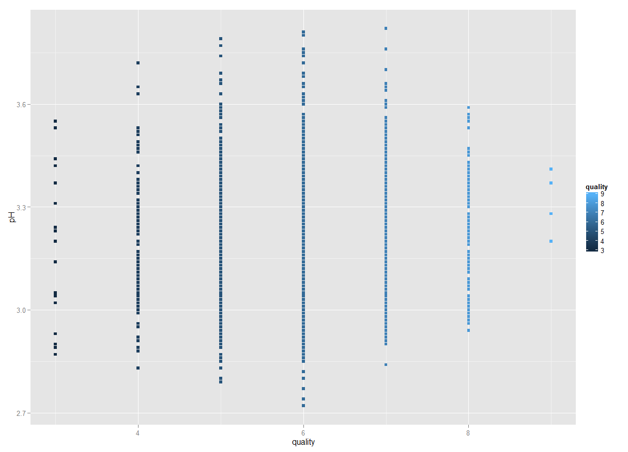geom_point(size=2, shape=15)